CS-340 Project Two: Grazioso Salvare Dashboard
Dashboard Documentation
Morgun Leonard
CS-340: Client/Server Development

Introduction
The purpose of this dashboard is to support the staff of Grazioso Salvare by providing an interactive interface for filtering, analyzing, and visualizing animal data relevant to rescue training selection. The dashboard integrates data from a MongoDB database through a custom CRUD module and displays results using interactive Dash components including tables, charts, and geolocation mapping.
This document explains how the dashboard meets client requirements, describes how the system functions, and includes annotated screenshots demonstrating the dashboard’s full functionality.
System Overview
Database Integration
The dashboard connects to a MongoDB instance using a custom Python module (CRUD_Python_Module.py). The module implements the basic CRUD methods required for retrieving filtered datasets.
Data is loaded into a Pandas DataFrame, cleaned, and then displayed in Dash components. All filtering actions are performed by sending MongoDB queries through the CRUD class based on user input from the dashboard’s controls.
Dashboard Components
Filtering Controls
Users select one of four rescue categories:
- Reset (All Dogs)
- Water Rescue
- Mountain or Wilderness Rescue
- Disaster or Individual Tracking

Each selection triggers a callback that issues a MongoDB query aligned with Grazioso Salvare’s preferred breed and age criteria.
Data Table
- Displays the filtered dataset
- Supports pagination, sorting, and native filtering
- Highlights selected columns
- Enables row selection to update the map view
Outcome Pie Chart
Each table filter updates a corresponding pie chart showing outcome_type distribution.
This helps the organization quickly understand the frequency of different outcomes (adoption, transfer, return to owner) across the filtered dataset.
Geolocation Map
The map displays the geographical coordinates of the selected row from the data table. A marker appears at the corresponding latitude/longitude with a popup displaying the animal’s name and tooltip showing the breed.
This helps visualize where animals were found or processed.

Screenshots and Annotations
Screenshot 1 — Reset Filter (Table View)
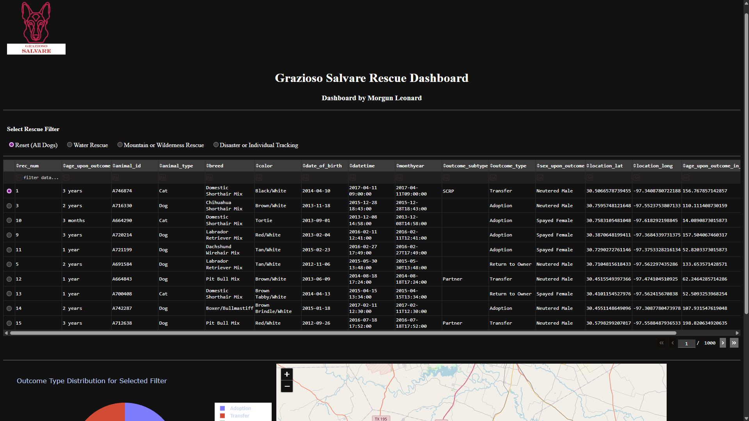This screenshot shows the full dashboard interface including the logo, title, rescue filter controls, and complete data table under the Reset (All Dogs) filter.
Screenshot 2 — Reset Filter (Pie Chart and Map)
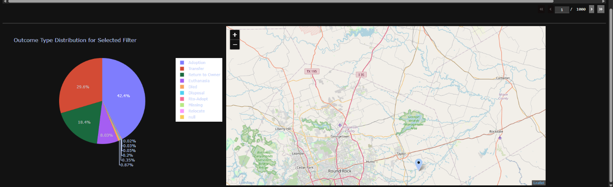
This screenshot displays the outcome type distribution for the unfiltered dataset and the map centered over Austin, TX with the default selection marker shown.

Screenshot 3 — Water Rescue Filter (Table View)
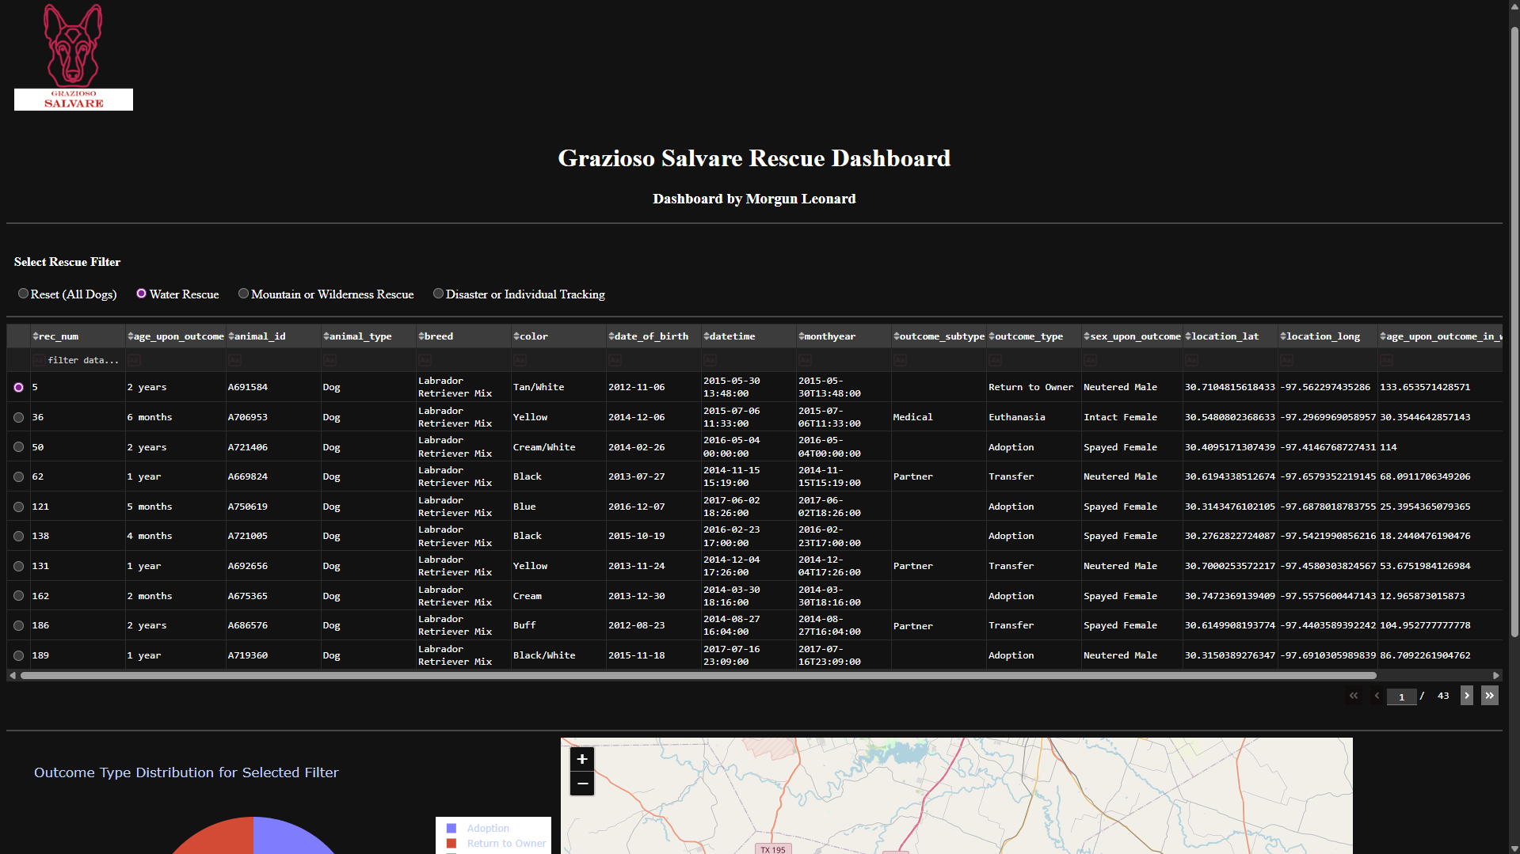
This table shows only dogs that meet the Water Rescue requirements (Labrador Retriever Mix, Chesapeake Bay Retriever Mix, or Newfoundland under three years old).
Screenshot 4 — Water Rescue Filter (Pie Chart and Map)
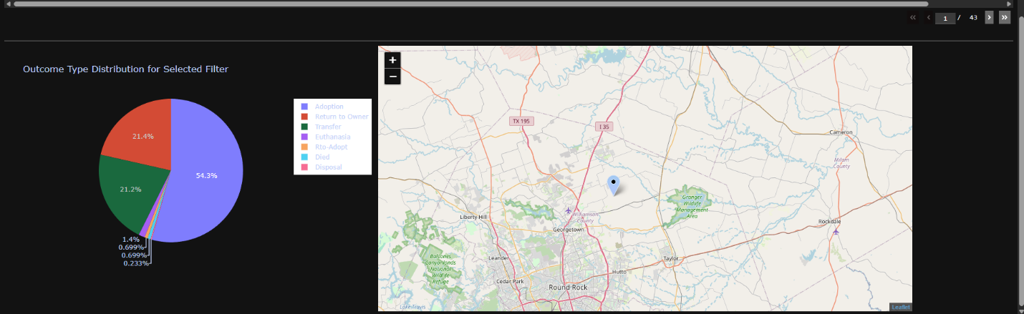
Updated pie chart showing the outcome distribution for Water Rescue candidates and the map showing the selected dog's geolocation.

Screenshot 5 — Mountain or Wilderness Rescue Filter (Table View)
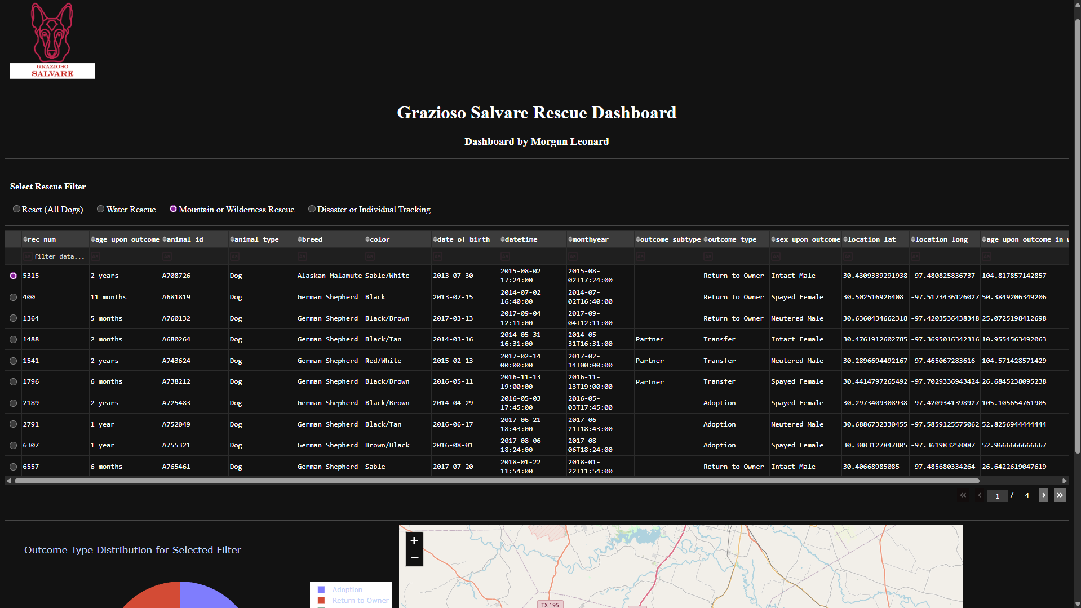
This table represents dogs filtered by Mountain/Wilderness Rescue criteria, displaying eligible breeds such as German Shepherd, Alaskan Malamute, and Siberian Husky under four years old.
Screenshot 6 — Mountain or Wilderness Rescue Filter (Pie Chart & Map)
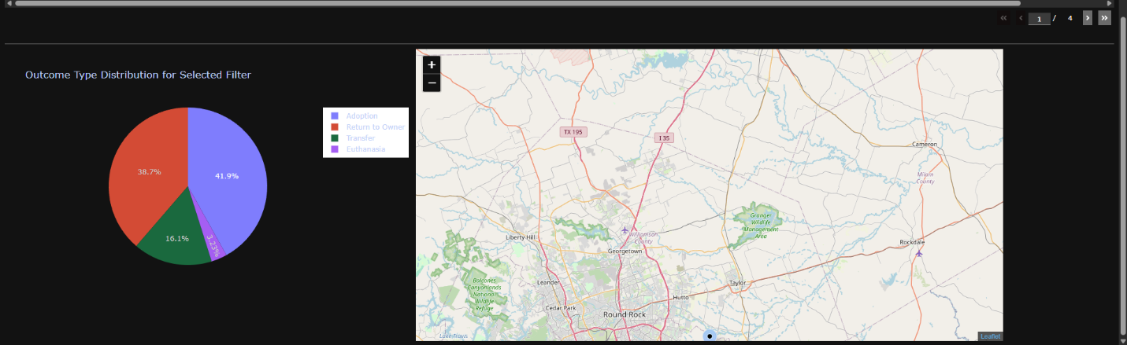
Outcome distribution pie chart and map updated based on the Mountain/Wilderness filter.

Screenshot 7 — Disaster or Individual Tracking Filter (Table View)
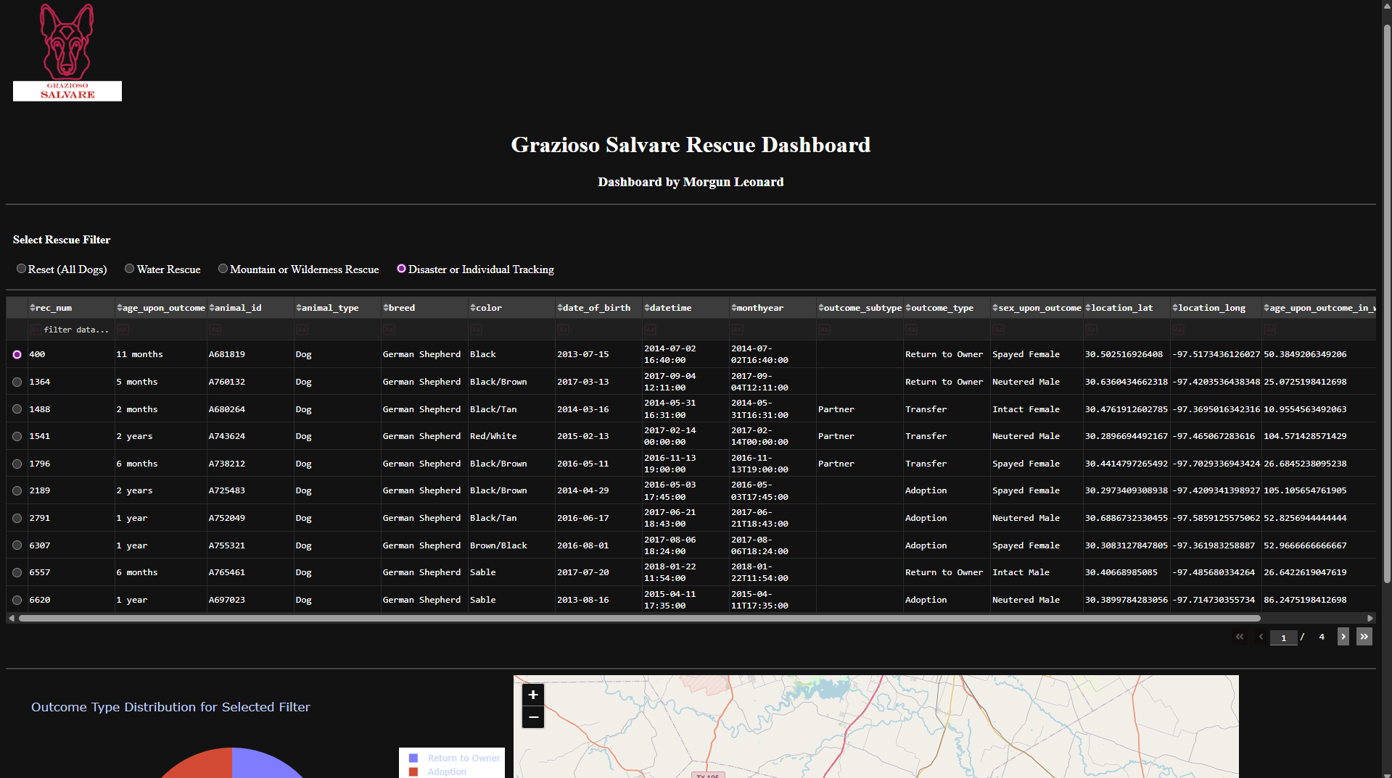
This filtered dataset displays the animals eligible for Disaster/Tracking roles, covering both disaster breeds and tracking breeds.
Screenshot 8 — Disaster or Individual Tracking Filter (Pie Chart & Map)
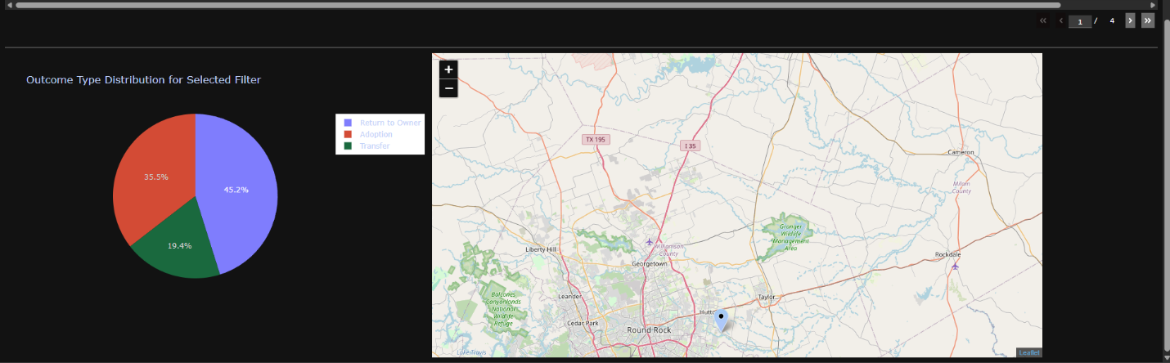
Updated pie chart and map results showing outcome distribution and location data for Disaster/Tracking filter selections.

System Interaction Explanation
How the Dashboard Uses MongoDB Queries
Each time the user selects a filter, the dashboard builds a corresponding MongoDB query using predefined criteria. These queries are sent to the database through the CRUD class, and results are dynamically passed to Dash components.
How the Data Table Interacts with the Map
- The table updates based on the filter selection
- Selecting a row triggers an event
- The system extracts location_lat, location_long, name, and breed
- The Leaflet map moves the marker to the correct coordinates
How Data Visualization Supports Decision Making
The pie chart helps identify the most common outcomes for each rescue group. This supports planning for:
- Training needs
- Adoption or transfer likelihood
- Intake and outcome forecasting
The map component helps the organization visualize animal distribution patterns.

Conclusion
The Grazioso Salvare Dashboard meets all project requirements by providing an interactive, data-driven, and user-friendly interface. The dashboard successfully integrates MongoDB, visualizes outcome trends, and provides location mapping for individual entries. This enables Grazioso Salvare to make informed decisions when selecting dogs for various rescue training programs.

